Retrieval Practice – Wednesday 4th December Name: ______________________ Block: _____
1. 3 weeks ago:
a. Calculate the spring constant of a 2cm spring that extends that to 5cm when a force of 12N is applied.

b. Calculate the energy stored when it is stretched in part a.

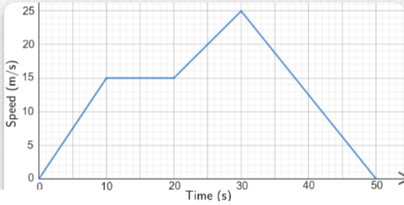
2. 5 weeks ago
Calculate the acceleration between 30 and 50 seconds.

Calculate the distance travelled in the first 20 seconds

3. Last week
A book is lifted to a height of 2m and dropped. The mass of the book Is 1kg.
- Calculate the gravitational potential energy of the book when it is lifted. g = 10N/kg.

- The book is dropped. Calculate how fast it is going when it hits the floor. Hint: Use kinetic energy.
Assume all the gpe = kinetic energy.

Retrieval Practice – Wed 20th November Name: ______________________ Block: _____
1. Last week
A cart of 1kg travelling at 10m/s hits AND STICKS TO another cart of 1kg that is stationary. Explain why the two carts travel at 5m/s after the collision. Use ‘momentum’ in your answer.

2. Two weeks ago
a. Suggest why a = F/m is better than F = ma.

b. A 200g mass has a forward force of 2kN on it, and a drag force of 0.5kN on it. Calculate the acceleration.

c. Draw a free body diagram for a leaf falling from a tree at a constant velocity. Label the forces

3.A while ago..
a. Calculate how many atoms there are in the height of the average human… i.e.1.5m tall.

b. If atoms were the size of apples (10cm big) how tall would a human be?

Retrieval Practice – Thursday 14th November Name: ______________________ Block: _____
1. One week:
a. A car is travelling at 20m/s at time = 0s. The car accelerates with an acceleration of 5m/s² for 3 seconds. Calculate the final velocity of the car.

b. Sketch a velocity time graph for this part of the journey with numbers on this graph:

2. Many weeks
The pressure at a bottom of a swimming pool due to the water ONLY is 30kPa. Calculate the depth of the pool. g = 10N/kg,
ρ = 1000kg/m³.

3. Sometime around August?
Describe the knowledge about the electron in each of the models of the atom that you learned about:
Model name/person | Knowledge about the electron/ how the electron featured in the model.

Retrieval Practice – Wednesday 6th November Name: ______________________ Block: _____
1. Last lesson:
a. Look at the graph. Calculate the acceleration in sections and SHOW ALL WORKING.
A

B

C

b. Calculate the total distance travelled in the graph in question 1

2. Two weeks aga
Explain why temperature is not a vector.

Give an example of something that is.

3. Three weeks ago
You notice your car tire pressure is low. You can pump up the tires in the morning when it is cold or in the afternoon when it is hot. Suggest and explain in terms of particles the potential problem with EACH time of day.

Retrieval Practice – Wednesday 30th October Name: ______________________ Block: _____
1. Last lesson:
Complete this Venn diagram for vectors and scalars: Put V and S in the correct sections of the diagram.
Magnitude Direction.

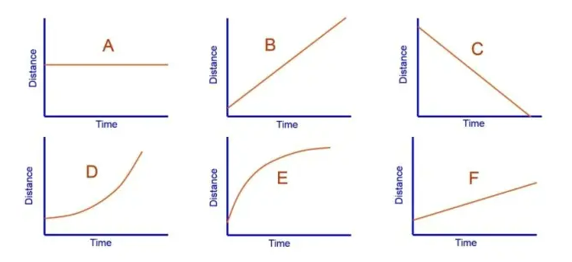
2. Last week
Give the letter or letters of the graph(s) that show
- Steady non-zero speed _________
- Stationary ____________
- Speeding up ____________
- Slowing down ____________
- Describe what is happening in graph C.

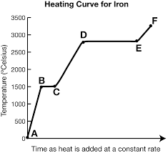
3. A while ago:
In which section or sections of the graph do particles have changing potential energy while kinetic energy is unchanging?

Explain your answer.

Retrieval Practice – Thursday 24th October Name: ______________________ Block: _____
1. Last week:
Here is some data about the speed of a cart. Use it to give the average and the uncertainty.
12m/s | 16m/s | 20m/s

2. A few weeks ago:
A rectangular block with an area of 2m² sinks to a depth of 10cm in water where it floats. Water has a density of 1000kg/m³. Gravitational field strength is 10N/kg.
- Calculate the water pressure at that depth

- Calculate the force of the water on the block.

3. Homework: An ice block with a temperature of –10 °C and a mass 10 kg is left to melt. Calculate the energy required to melt the ice and bring the water up to 20°C..
SHC of ice = 2090J/kg/ºC. SLH of fusion of water = 334 000 J/kg, SHC water = 4200J/kg/ºC. You need to do 3 calculations and add them.

Retrieval Practice – Wed 9th October Name: ______________________ Block: _____
1. Last week:
Sketch a graph of pressure against volume, and a graph of pressure against 1/volume.

2. Three weeks ago:
Explain why the specific latent heat of vaporisation is bigger than the specific latent heat of fusion.

3. A while ago
Calculate the mass of air in a room that is 10m x 10m x 3m. The density of air is 1.3kg/m³.

Retrieval Practice – Wed 9th October Name: ______________________ Block: _____
1. Last week:
Sketch a graph of pressure against volume, and a graph of pressure against 1/volume.

2. Three weeks ago:
Explain why the specific latent heat of vaporisation is bigger than the specific latent heat of fusion.

3. A while ago
Calculate the mass of air in a room that is 10m x 10m x 3m. The density of air is 1.3kg/m³.

Retrieval Practice – Wed 25th Sept Name: ______________________ Block: _____
1. Last week:
a. What is the difference between specific heat capacity and specific latent heat? (NOT units – definitions)

b. Calculate the energy needed to vaporize 1.3g of water if the specific latent heat of vaporization of water is 2 265 000 J/kg. Round your answer to 2 significant digits.

2. Three weeks ago:
a. Use the graph to find the boiling point of iron. (approximately)
Temperature = ___________
3. A while ago
A molecule is 5.3 x 10⁻⁸m long. How many atoms are in it? Show working.

Retrieval Practice – Wed 25th Sept Name: ______________________ Block: _____
1. Last week:
a. What is the difference between specific heat capacity and specific latent heat? (NOT units – definitions)

b. Calculate the energy needed to vaporize 1.3g of water if the specific latent heat of vaporization of water is 2 265 000 J/kg. Round your answer to 2 significant digits.

2. Three weeks ago:
a. Use the graph to find the boiling point of iron. (approximately)
Temperature = ___________
3. A while ago
A molecule is 5.3 x 10⁻⁸m long. How many atoms are in it? Show working.

Retrieval Practice – Wednesday 18th September Name: ______________________ Block: _____
1. Last week:
Calculate the energy in joules to melt 20g of chocolate. The specific latent heat of melting of chocolate is 46 kJ/kg. CAREFUL with units. 1000g in 1kg. 1000J in 1kJ.

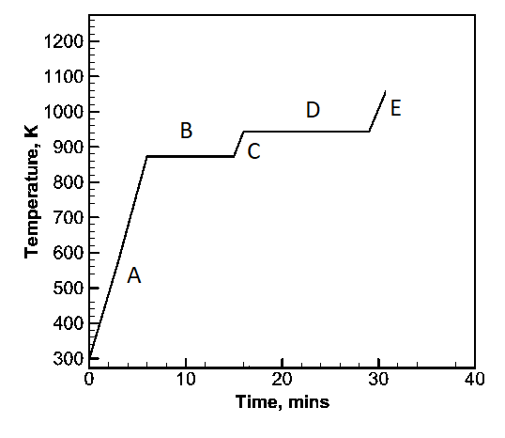
2. Two weeks ago:
In which section or sections of the graph is the average kinetic energy increasing? _______________
Explain.

3. Three weeks ago
Why is liquid mercury denser than water?

Retrieval Practice – Wednesday 18th September Name: ______________________ Block: _____
1. Last week:
Calculate the energy in joules to melt 20g of chocolate. The specific latent heat of melting of chocolate is 46 kJ/kg. CAREFUL with units. 1000g in 1kg. 1000J in 1kJ.

2. Two weeks ago:
In which section or sections of the graph is the average kinetic energy increasing? _______________
Explain.

3. Three weeks ago
Why is liquid mercury denser than water?

Retrieval Practice – Wed 11th Sept Name: ______________________ Block: _____
1. Last week: Calculate the energy transferred to a cup of water of mass 400g when the temperature rise is 80ºC The specific heat capacity of water is 4200 J/kgºC. Use the formula sheet.

2. Two weeks ago: Calculate the density of a material for which a 200cm³ block has a mass of 25g? Use the formula sheet. Use the units as given.

3. Three weeks ago Calculate the number of atoms in the length 1cm.

Retrieval Practice – Wed 11th Sept Name: ______________________ Block: _____
1. Last week: Calculate the energy transferred to a cup of water of mass 400g when the temperature rise is 80ºC The specific heat capacity of water is 4200 J/kgºC. Use the formula sheet.

2. Two weeks ago: Calculate the density of a material for which a 200cm³ block has a mass of 25g? Use the formula sheet. Use the units as given.

3. Three weeks ago Calculate the number of atoms in the length 1cm.

Retrieval Practice – Wed 4th Sept Name: ______________________ Block: _____
1. One lesson ago:
a. Draw particle pictures of a solid, a liquid and a gas. | b. Give one reason why two solids can have different densities.
2. Last week:
Which particles did Geiger and Marsden fire at a gold foil? What happened? What did it mean? (that’s 3 things)

3. One week ago:
How many atoms in a molecule that is 20 x 10⁻¹⁰m long? Show your working.

Retrieval Practice – Wed 4th Sept Name: ______________________ Block: _____
1. One lesson ago:
a. Draw particle pictures of a solid, a liquid and a gas. | b. Give one reason why two solids can have different densities.
2. Last week:
Which particles did Geiger and Marsden fire at a gold foil? What happened? What did it mean? (that’s 3 things)

3. One week ago:
How many atoms in a molecule that is 20 x 10⁻¹⁰m long? Show your working.

Retrieval Practice – Wednesday- 28rd August Name: ______________________ Block: _____
1. One lesson ago:
Name 3 things that make a graph NOT good.

2. One lesson ago:
What’s the difference between accurate and precise?

3. One week ago:
When do you draw a line graph?

When do you draw a bar chart?.

Retrieval Practice – Wednesday 28rd August Name: ______________________ Block: _____
1. Last week:
Name 3 things that make a graph NOT good.

2. Last week:
What’s the difference between accurate and precise?

3. One week ago:
When do you draw a line graph?

When do you draw a bar chart?.

Retrieval Practice – Wednesday 21st August Name: ______________________ Block: _____
1. One lesson ago:
What is the independent variable in your investigation? ______________________________________
What is the dependent variable in your investigation? ______________________________________
2. One lesson ago:
Circle the correct word in bold in each sentence:
Time is a continuous/discrete/categoric variable
Color is a continuous/discrete/categoric variable
Type of shoe is a continuous/discrete/categoric variable
3. Two lessons ago:
What is SLOP?

Retrieval Practice – Wednesday 21st August Name: ______________________ Block: _____
1. One lesson ago:
What is the independent variable in your investigation? ______________________________________
What is the dependent variable in your investigation? ______________________________________
2. One lesson ago:
Circle the correct word in bold in each sentence:
Time is a continuous/discrete/categoric variable
Color is a continuous/discrete/categoric variable
Type of shoe is a continuous/discrete/categoric variable
3. Two lessons ago:
What is SLOP?

